**Chapter 1**

**Essential SQL**

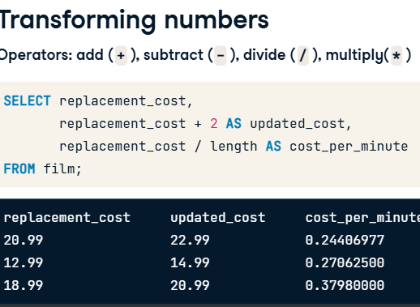

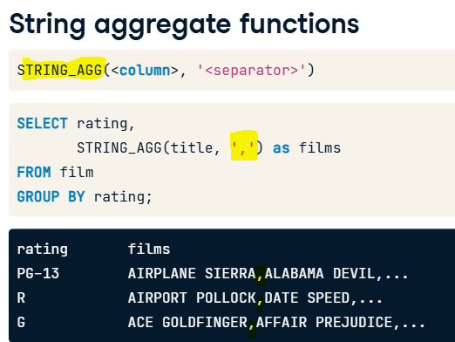

**Chapter 2**

**Finding the right table**

* **Complex joins**

**Chapter 3**

**Store your data**

**Chapter 4**

**Convey your intent**

